Lab - Setup Sonarqube

In this lab, we will set up an open source sonarqube code scanning tool and scan the application code to identify the security vulnerabilities, code smells and other code issues

Learning Objective -
- Setup Sonarqube using docker and docker compose.
- Scan the Java Code manually
- Understand the sonarqube report.

Pre-requisite -
- A linux virtual machine with docker and docker compose installed on it.
- Make sure port 9000 is enabled on the virtual machine

PS - Follow the instructions here to install docker.
Also, to run docker without sudo, run the following command

sudo usermod -aG docker $USER
newgrp docker

Steps to follow -
- Download and install the Sonarqube server with its database.
- Explore the sonarqube server
- Setup and manually scan the Nodejs application code
- Explore report generated by Sonarqube server

Step-by-step guide

Setup Sonarqube
- Connect to the virtual machine where you want to install Sonarqube.
- Clone this repository. This is a public repository so you won’t need credentials.
- The above repository has a docker-compose.yml file that has the definition to deploy a sonarqube with all its components.
- Execute docker compose up -d command

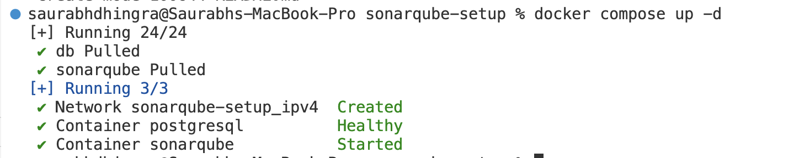

- Access the Sonarqube by navigating to the browser and enter the url as http://<ip_address>:9000

Note: Make sure port 9000 is enabled if you are using a virtual machine

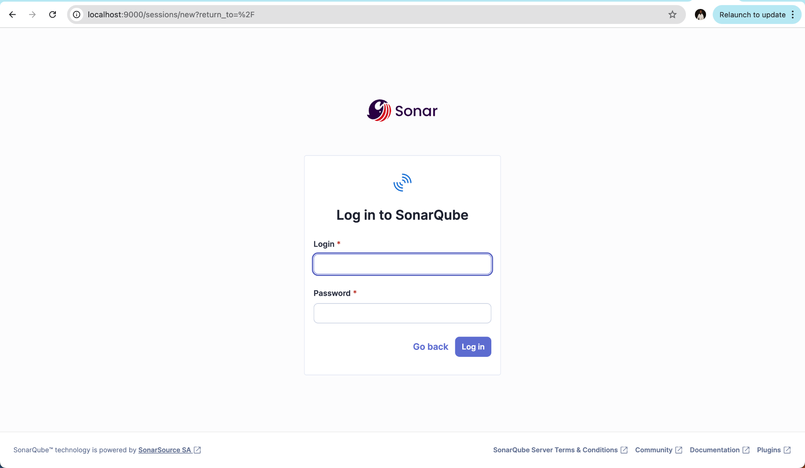

Enter the username as admin and password as admin and click Log in
Next screen will ask to change the password. Enter password of your choice.

The next page is the welcome page of Sonarqube.

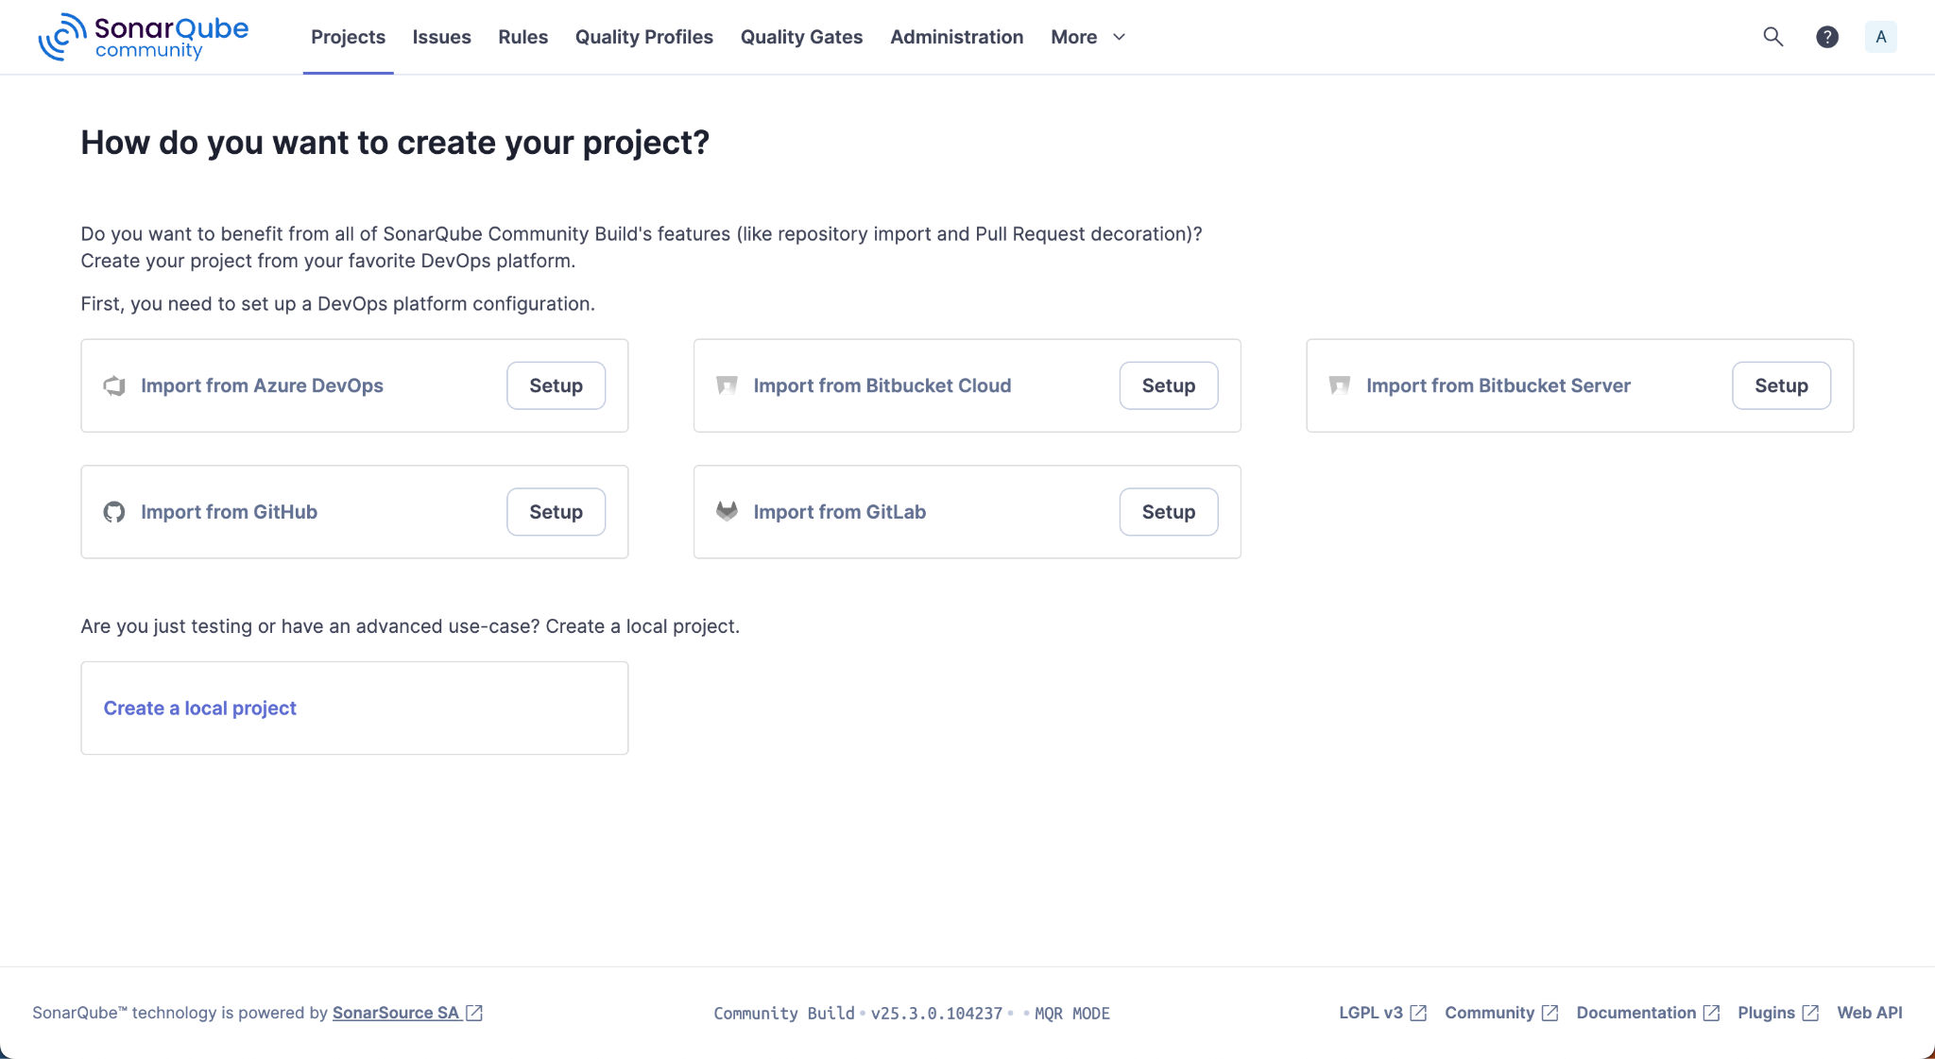

Next, we will manually scan the application code we used in the previous lab.

Scanning Code

Select Create a local project

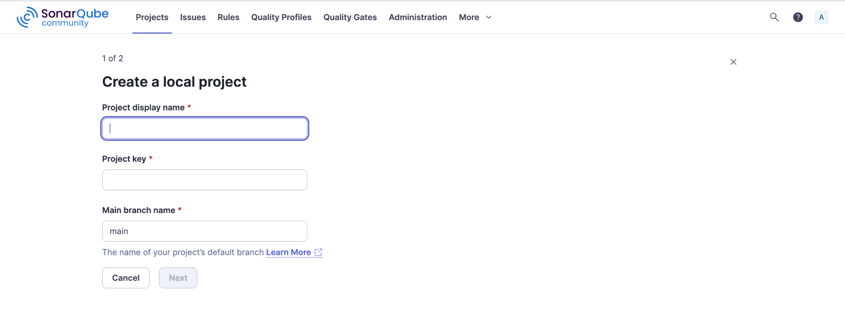

Enter Project Display Name - Sample Java Project
Enter Project Key - <it will automatically populate the key>
Branch Name - main
Click Next

Next, Select the first option ‘Use the global setting’ and click Create Project

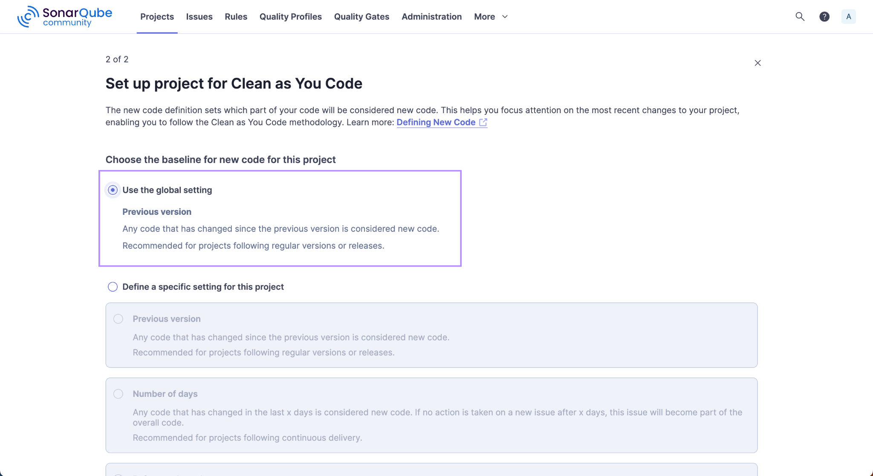

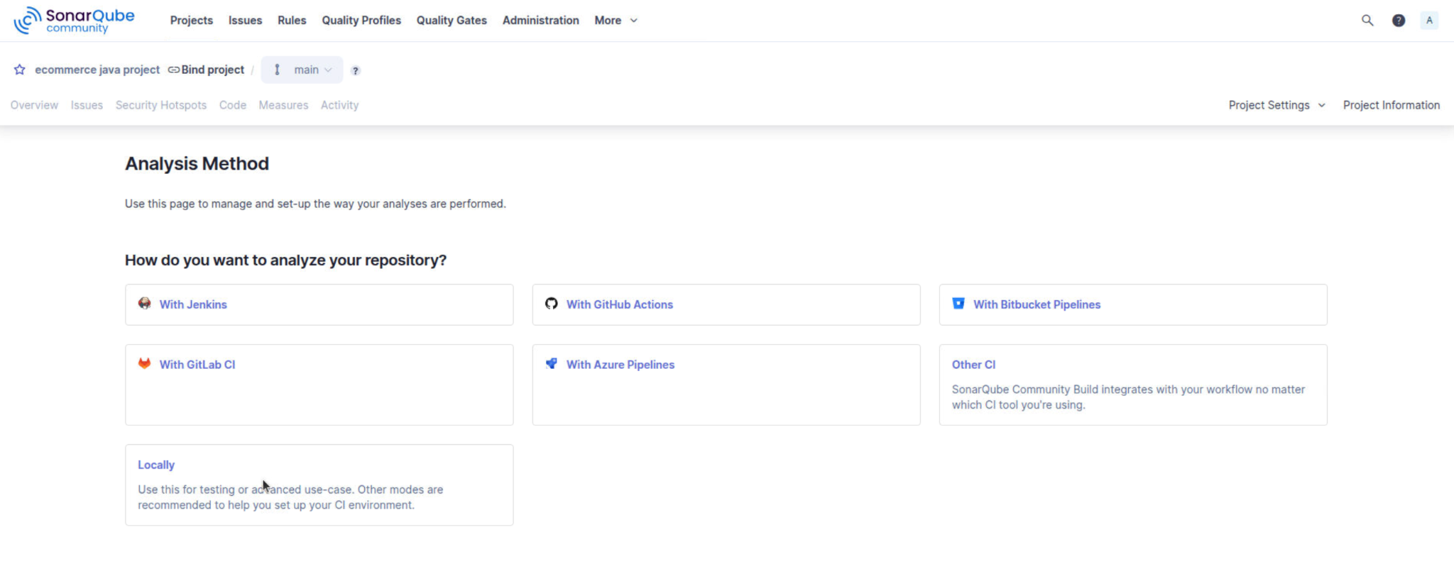

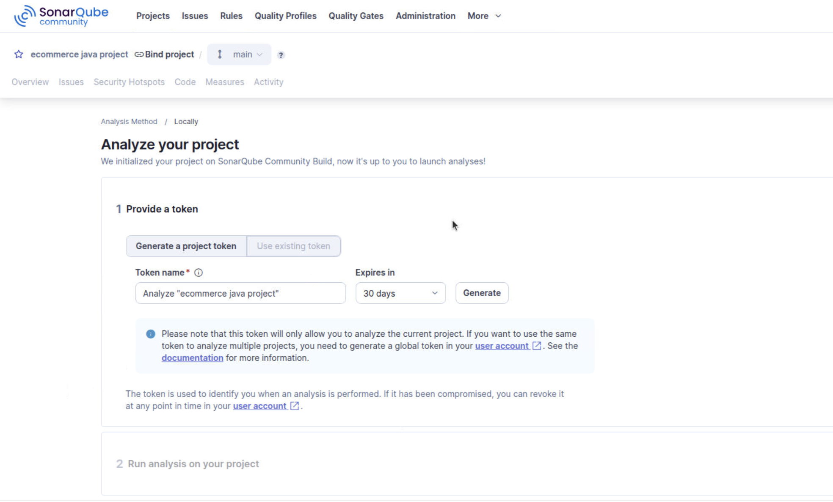

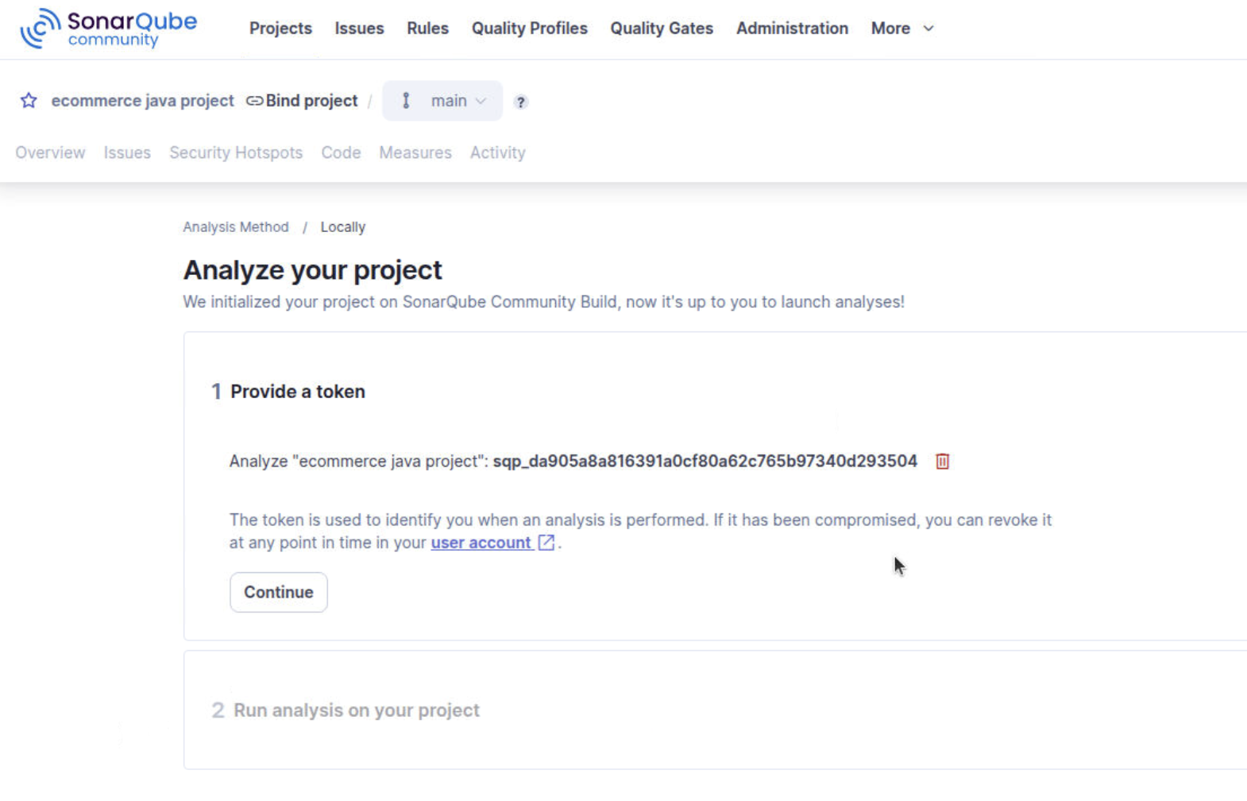

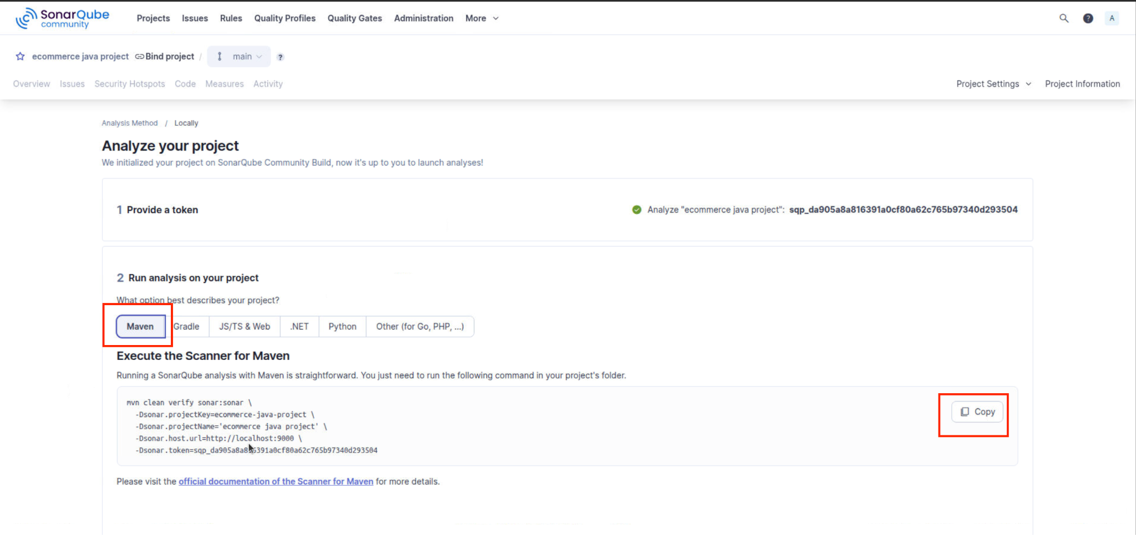

Click Copy. This is the command we need to run to compile the code.

Next, we need the code to execute this command.

Clone the code repository from here - Ecommerce Sample Java Application

Make sure you have Java and Maven installed on your machine.

You can run the following command to install Maven.

sudo apt update

sudo apt install maven -y

mvn -version

Switch to the code directory and execute the command copied from above

mvn clean verify sonar:sonar \
-Dsonar.projectKey=ecommerce-java-project \
-Dsonar.projectName='ecommerce java project' \
-Dsonar.host.url=http://localhost:9000 \
-Dsonar.token=<enter your token here>

Note - Make sure to change the token in the above command.

Once the execution completes, switch to the Sonarqube web application on the browser and you will see the project execution.

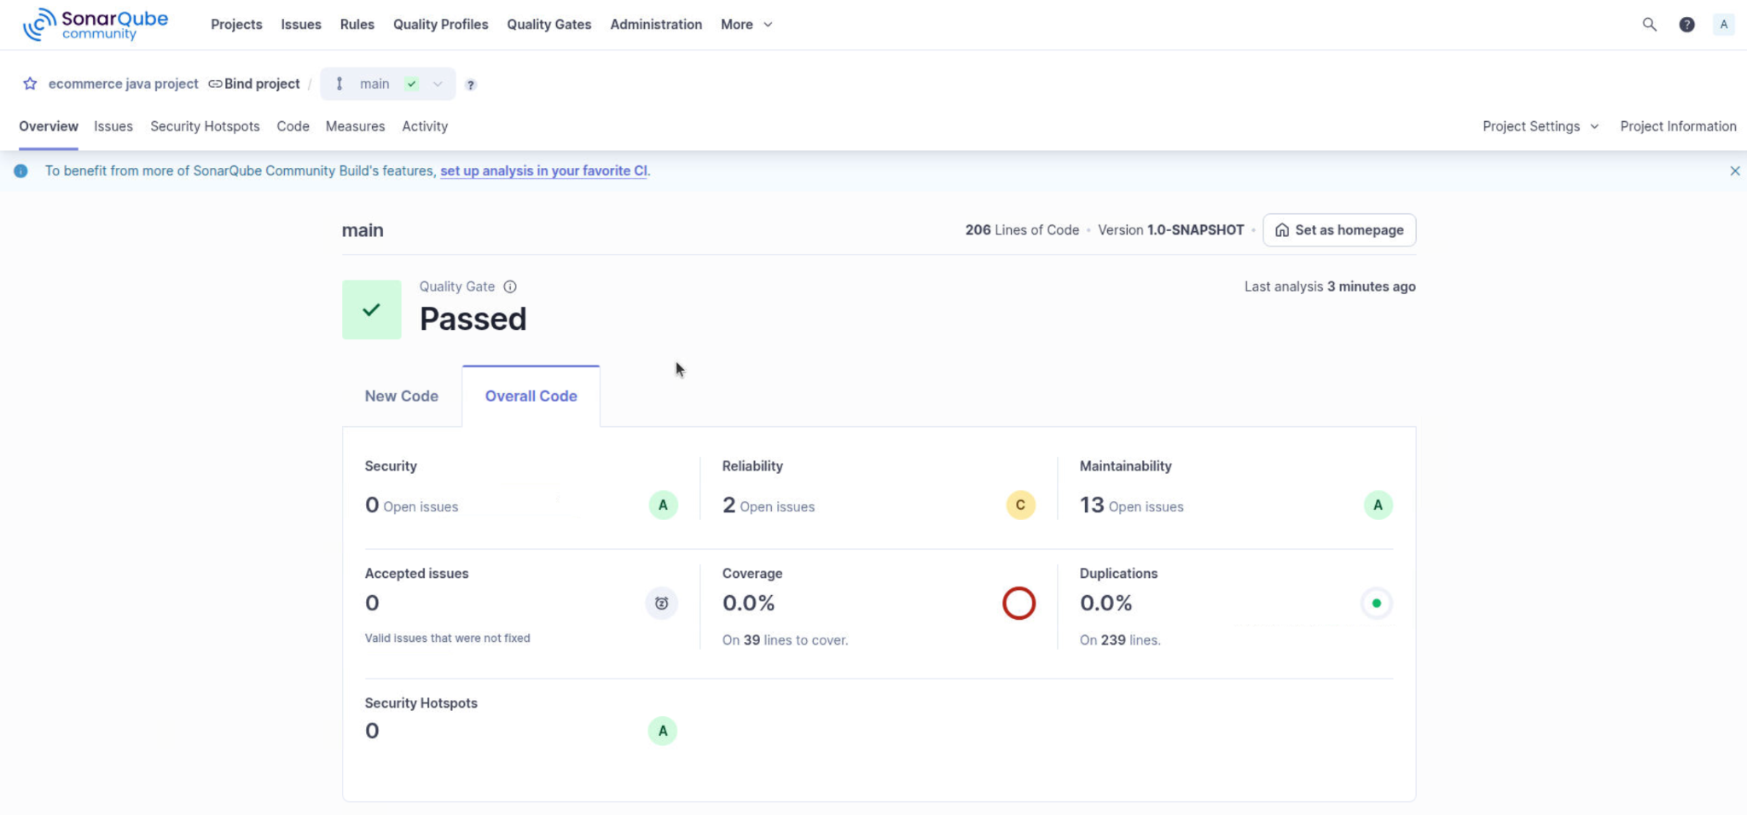

Navigate through the report to know about the code quality of this application.

Congratulations, you have successfully scanned the code using Sonarqube!

